Trabajo Práctico Nº 2
Expected answers

DISK GEOMETRY

Disks are constructed from platters. Each platter consists of two sides, or surfaces, that are coated with magnetic recording material. A rotating spindle in the center of the platter spins the platter at a fixed rotational rate, typically between 5400 and 15,000 revolutions per minute (RPM). A disk will typically contain one or more of these platters encased in a sealed container.
Figure 6.9 (a) shows the geometry of a typical disk surface. Each surface consists of a collection of concentric rings called tracks. Each track is partitioned into a collection of sectors. Each sector contains an equal number of data bits (typically 512 bytes) encoded in the magnetic material on the sector. Sectors are separated by gaps where no data bits are stored. Gaps store formatting bits that identify sectors.
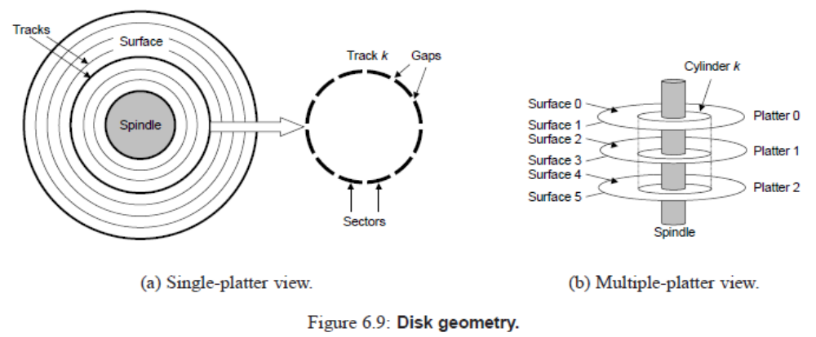
A disk consists of one or more platters stacked on top of each other and encased in a sealed package, as shown in Figure 6.9 (b). The entire assembly is often referred to as a disk drive, although we will usually refer to it as simply a disk. We will sometime refer to disks as rotating disks to distinguish them from flash-based solid state disks (SSDs), which have no moving parts.
Disk manufacturers describe the geometry of multiple-platter drives in terms of cylinders, where a cylinder is the collection of tracks on all the surfaces that are equidistant from the center of the spindle. For example, if a drive has three platters and six surfaces, and the tracks on each surface are numbered consistently, then cylinder k is the collection of the six instances of track k.

Disk Operation
Disks read and write bits stored on the magnetic surface using a read/write head connected to the end of an actuator arm, as shown in Figure 6.10 (a). By moving the arm back and forth along its radial axis, the drive can position the head over any track on the surface. This mechanical motion is known as a seek. Once the head is positioned over the desired track, then as each bit on the track passes underneath, the head can either sense the value of the bit (read the bit) or alter the value of the bit (write the bit). Disks with multiple platters have a separate read/write head for each surface, as shown in Figure 6.10 (b). The heads are lined up vertically and move in unison. At any point in time, all heads are positioned on the same cylinder.
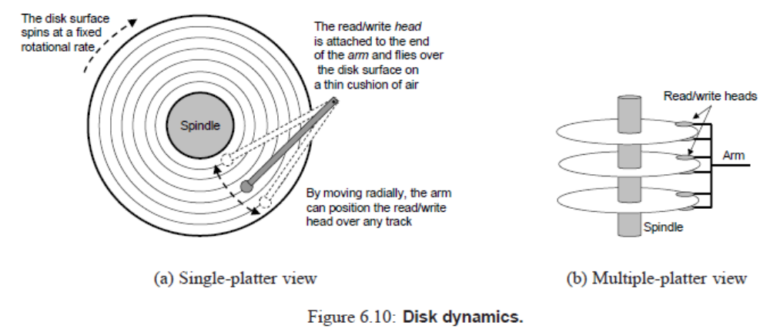
EJERCICIO 1

A. Antes de leer el texto preste atención a los dos títulos, ¿sobre qué cree que tratará cada parte? ¿Qué otro elemento nos permite anticipar el contenido del texto?

La primera parte tratará sobre la geometría de los discos, su composición y, la segunda, sobre la operación de los discos, su funcionamiento. Las figuras.

B. Indique en cuál de las dos partes del texto cree que se encontrarán estas ideas. Una con flechas.
 | Definición de cilindro. DG
 | Movimientos del cabezal. DO
DISK GEOMETRY | Concepto de pistas y sectores. DG | DISK OPERATION
 | Composición física de un disco. DG
 | Mecanismos de lectura y escritura en el disco. DO

C. Ahora lea todo el texto y corrija o confirme lo anterior.

EJERCICIO 2

- Ubique estas palabras junto a sus equivalentes en inglés en las Figuras 6.9 y 6.10:
sectores - brazo - espacios – eje – superficie – cabezales de lectura y escritura – pista – platillo – cilindro
sectors-arm-gaps-spindle-surface- read/write heads-track-platter-cylinder

B. ¿Qué dos vistas nos presenta cada figura?
(a) vista de un solo platillo (b) vista de múltiples platillos

EJERCICIO 5

Las siguientes frases nominales fueron extraídas del texto. Elija la traducción correcta en cada caso.

1. A rotating spindle in the center of the platter
a. un eje giratorio en el centro del platillo
b. un platillo en el centro del eje giratorio

2. a fixed rotational rate
a. una velocidad de rotación fija
b. una rotación de velocidad fija

3. rotating disks
a. rotación de discos
b. discos giratorios

4. flash-based solid state disks
a. memoria flash basada en los discos de estado sólido
b. discos de estado sólido (SSD) basados ​​en memoria flash

5. the collection of tracks on all the surfaces
a. todas las superficies en el conjunto de pistas
b. el conjunto de pistas en todas las superficies

